PASSIVE MONITORING TEMPLATE EMAIL/LETTER
NAME
DATE of BIRTH
ADDRESS
CONTACT NUMBER
CONTACT EMAIL
GP DETAILS | Permission provided to contact GP, if needed:  YES ☐ NO ☐ Not Asked ☐
DATE of MPOX EXPOSURE
DATE of LAST DAY of ACTIVE MONITORING

Dear [INSERT NAME]
You have been identified as a close contact of a case of mpox. You have been placed under passive monitoring by the Medical Officer of Health for 21 days since your contact with a confirmed case of mpox. Passive monitoring means that you should monitor yourself and how you are feeling, and if you develop any symptoms, you should immediately self-isolate, leave work, seek medical review (i.e. GP, Out of Hours Services, Emergency Room, Sexual Health Services) and abstain from all sexual contact.

Being under passive monitoring can feel intrusive. However, to ensure you do not pass any infection on to others, it is extremely important that you:
- Follow the directions for passive monitoring, for 21 days.
- Ensure you wash your hands frequently and practice respiratory etiquette, information can be found here.
- Abstain from sexual contact for the period of your monitoring.

You should avoid undertaking any travel, including international travel, until they are determined to no longer constitute a public health risk for others.
You can attend work/school as usual and undertake normal social activities. However, it is important that for the 21 days following your contact with the case, you monitor yourself for the early symptoms of mpox. If you work/attend school that involves, contact with immunocompromised people, pregnant women, or children under 5 years (not limited to H&CWs). Risk assessment around redeployment to different area may be considered, so you might need to link with Line Manager, if this is required.
Please use this form to record your temperature twice daily (when you get up in the morning and during the evening before you go to bed) using a digital thermometer, and to record any symptoms you develop during this period. You can return your completed form to your regional Department of Public Health.

If you feel unwell at any time, please take your temperature. Make sure to take your temperature in your mouth (and not under your arm). Follow the manufacturer’s instructions on use. Leave at least 20 minutes between taking exercise or consuming warm or cold drinks or food and checking your temperature. If you feel unwell in any way, please check your temperature. If you develop symptoms, you should exclude yourself from work, self-isolate and call your GP/health provider immediately. You should also abstain from any sexual contact. Whenever you call your GP/health provider make sure to tell them you are a mpox contact.

If you develop a fever or any of the symptoms below, you should call your GP/health provider. If you are feeling very unwell then you should seek medical attention.
In case of an emergency call 112/999 and advise them that you have had contact with a case of mpox.
The symptoms of mpox are:
- Rash that may be painful or itchy (may look like pimples or blisters to start);
- Fever (temperature at or above 38.5°C);
- Chills;
- Swollen lymph nodes;
- Exhaustion;
- Muscle aches and backache; and
- Headache.
People may experience all or only a few symptoms. Others only experience a rash.

Images of mpox lesions
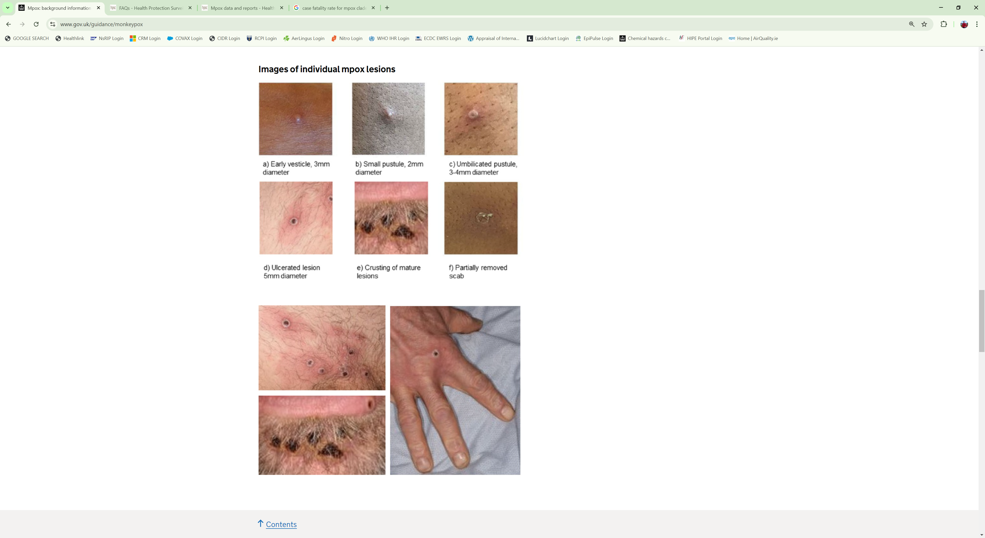

You can visit these websites for fact-based information about mpox:
- HSE website: https://www2.hse.ie/conditions/mpox/
- HPSC website: https://www.hpsc.ie/a-z/zoonotic/monkeypox/

If you have any questions, feel free to contact you regional Department of Public Health.

Yours sincerely,

[NAME, TITLE, and CONTACT INFORMATION]

Daily Log for Contact (to be completed by contact and returned to regional Department of Public Health)
Day | Date  dd/mm/yyyy | AM – Temperature | PM – Temperature | Other Symptoms (Y/N) (Describe)
1
2
3
4
5
6
7
8
9
10
11
12
13
14
15
16
17
18
19
20
21

If you develop any symptoms, you should immediately self-isolate, leave work, seek medical review (i.e. GP, Out of Hours Services, Emergency Room, Sexual Health Services) and abstain from all sexual contact.

